Towradgi Public School
OFFICE USE ONLY
Receipt ______________
Date ________________
Paid ________________
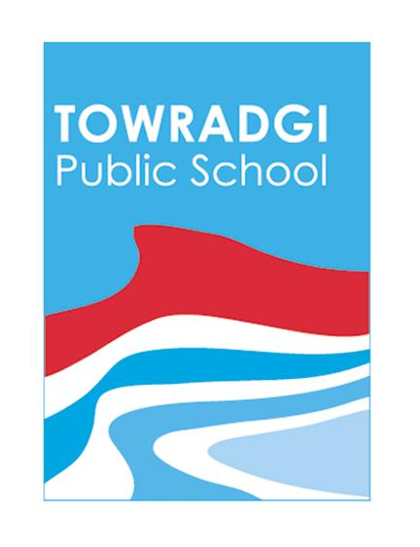
Item  (** Sizes 4,6,8,10,12,14,16 **) | Size | Price | Qty | Total  $ | Fill Date  (Office Use)
Short sleeved polo shirt (with emblem logo) |  | $18.00
Long sleeved polo shirt (with emblem logo) |  | $20.00
Jumper (with emblem logo) |  | $20.00
Girl’s boot leg stretch pants (like Jazz pants) |  | $19.50
Girl’s culottes |  | $22.00
Boys’ long gabardine pants |  | $20.00
Boys’ cargo shorts |  | $19.00
Sports shirt unisex (with emblem logo) |  | $26.00
Sports short unisex |  | $16.00
School track pants |  | $26.00
School Jackets (with emblem logo) |  | $37.50
Broad Brim Hat (purchase from office) |  | $ 9.50
Uniform Order Form

Total Enclosed:$_____
Name: ________________ Class: _____ Contact No: _____________
Other arrangements: ___________________________________________
** Sizes 4,6,8,10,12,14,16 **
** Sun safe broad brimmed hats available at the office $9.50 each (Please try to have the right change if possible)**
- Payments can be made by way of:
Bank Transfer as follows:
Account Name: Towradgi Public School P&C Association
BSB: 062 537 Account: 00900067
Reference: Your Surname
Please provide proof that you have transferred this money so that order can be filled. A screen shot or print out of bank deposit confirmation is appreciated.
Cash or cheques made out to Towradgi Public School P & C.
- Items are not ordered on an individual basis - please ask when next order will be placed if there is any urgent need for an item. Please allow up to a week for your order to be filled. (8 to 10 weeks for sports uniform orders).
- Orders will be sent home with student unless other arrangements are made.
- When returning items they should have all tags attached and receipt should be with items. You have 5 days to return wrong sizes.
- Uniforms orders are completed through the kindness of a volunteer parent who may not be at the school every day.

